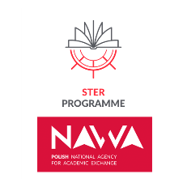
Art school financed by NAWA STER
Project title: Internationalization for Training and research Excellence
Agreement no:: BPI/STE/2021/1/00015/U/00001

International Art School For Doctoral Candidates

We invite all interested doctoral candidates to take part in our intensive international Weekend School, which will be held at the University of the National Education Commission, Krakow (ul. Podbrzezie 3) on December 18-20, 2023. Participants will receive a NAWA-affiliated certificate of completion. The registration for this free event is open until Friday, December 15. The number of places is limited, the registration date will be the only criterion of selection.

Monday, December 18 - UKEN ul. Podbrzezie 3 room 2.6
Basia Sliwinska
Generous Feminisms & Caring Activisms
Group 1
13:30 - 16:30
16:30-17:00- lunch break
Group 2
17:00 – 20:00
Basia Sliwinska, PhD, is a Researcher at the Art History Institute (Universidade NOVA de Lisboa, Portugal). Her work is situated within feminist art history, theory and practice, focusing on visual activism and artivism within transnational global frameworks. Basia is on the Editorial Board of Third Text. In 2023 she joined the Humanities Research Centre at the Australian National University as a Visiting Fellow. She is currently working on a solo-edited book My body, my choice: transnational visual activism for women’s reproductive rights (Routledge 2024).
Tuesday, December 19 - UKEN ul. Podbrzezie 3 room 2.6
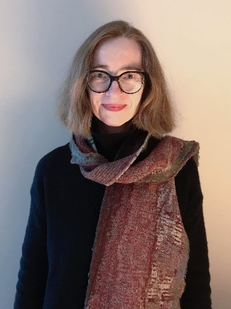
Elke Krasny
Concerns of care
Group 1
13:30 - 16:30
16:30-17:00- lunch break
Group 2
17:00 – 20:00
Elke Krasny is Professor of Art and Education at the Academy of Fine Arts Vienna, Institute of Art Education. She directs the Art and Education programme. As a cultural theorist and curator, Krasny researches issues of care and social reproduction, social and ecological justice, transnational feminism, as well as memory work and the politics of history in contemporary art, architecture, curatorial practice and art education.

Wednesday, December 20 - UKEN ul. Podbrzezie 3 room 2.6
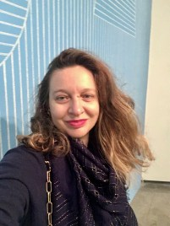
Giulia Lamoni
Concerning contemporary art, feminisms and activism
Group 1
13:30 - 16:30
16:30-17:00- lunch break
Group 2
17:00 – 20:00

Giulia Lamoni is an academic and art writer with an independent curatorial practice, who conducts research and teaches. Her research focusses on the relations between contemporary art and feminisms, contemporary artistic production and migratory processes, the histories of contemporary art in Latin America through the articulation of transnational perspectives, and the histories of the relations between artistic practices and experimental art education.

