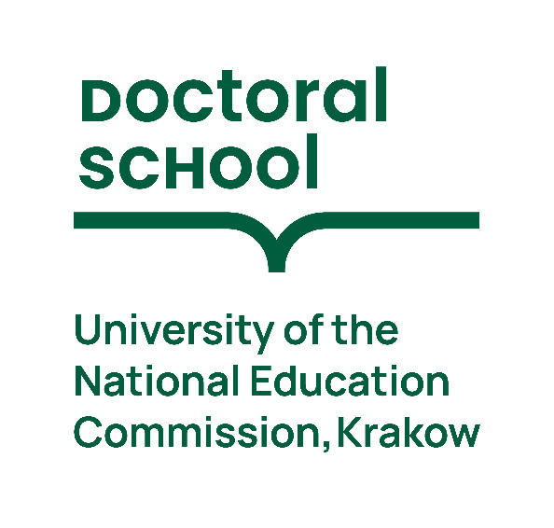
International Summer School
Young Researcher’s Workshop

14-15 October, 2026
Aula A1 (new building)
Podchorążych 2

Completing the Research Process Ethically with GenAI
Lecturer: dr Przemysław Tomczyk

PROGRAM

Day 1 – 14.10.2026 From Research Idea to Literature-Based Contribution
10:30 – 10:45 – welcoming the participants
10:45 – 12:15 – Research Problem Identification and Research Design
12:15 – 12:30 – break
12:30 – 14:00 – Literature Search and Evidence Identification
14:00 – 14:30 – welcome address to first-year doctoral students by the Vice Rector for
Research and the Directors of the Doctoral School
14:30 – 15:00 – break
15:00 – 16:30 – Literature Analysis and Synthesis
16:30 – 16:45 – break
16:45 – 18:15 – Building the Conceptual Framework

Day 2 – 15.10.2026 From Empirical Analysis to Manuscript Drafting
09:30 – 11:00 – Quantitative Research and Hypothesis Testing
11:00 – 11:15 – break
11:15 – 12:45 – Qualitative Research and Interpretation
12:45 – 13:30 – break
13:30 – 15:00 – Drafting the Scientific Manuscript
15:00 – 15:15 – break
15:15 – 16:45 – Reviewing, Improving and Preparing for Submission

